State Level Development Indicator And MGNREGA Employment
A Personal Data Analytics Project
Author-Aryan Yadav
2026

R|RStudio|MySQL|Regression Analysis

Contents
INTRODUCTION 3
METHODOLOGY 4
TECHNICAL ASPECT 6
RESULT 7
INTERPRETATION 12
CONCLUSION 14
Real-World Application And Policy Implications 15
REFERENCE AND DATA SOURCES 16

INTRODUCTION
Mahatma Gandhi National Rural Employment Guarantee Act (MGNREGA) 2005, replaced by Viksit Bharat-G RAM G Act 2025 is an act to establish a rural development framework aligned with the national vision of Viksit Bharat @2047, by providing a statutory guarantee of one hundred and twenty five days of wage employment from 1st of July 2026 (MGNREGA 2005 provided 100 days of wage employment) in every financial year to every rural household whose adult members volunteer to undertake unskilled manual work, to promote empowerment, growth, convergence and saturation for a prosperous and resilient rural Bharat and for matters connected therewith or incidental thereto. The Act, by definition, aims to provide employment opportunities to people lacking skills or people in need of employment. Thus, the high demand for employment under MGNREGA 2005 reflects a lack of either skills or employment opportunities with better income. This project aims to find an association between the indicator, particularly Education Quality, using the Sustainable Development Goals Index from 2020, data on MGNREGA from 2025-2026 and how they relate to employment under MGNREGA.
The 5-year gap between MGNREGA data and the Sustainable Development Goals Index data is intentional as part of the 5-year forward-lag analysis of this project. We have chosen this 5-year gap because development conditions measured in a state/UTs takes time to be reflected.
Since this study has been conducted on data from the year 2025-2026, the findings include employment patterns under the original MGNREGA framework prior to the 2026 transition to Viksit Bharat-G RAM G Act.

METHODOLOGY
- A good education not only makes a person productive, it also opens doors for acquiring new skills. Thus, we start this project by proposing a
Alternate Hypothesis (H₁)-Education quality has a significant association with the percentage of the population employed under MGNREGA.
Null Hypothesis (H₀)-Education quality does not have any significant association with the percentage of the population under MGNREGA.
- For this project, I used NITI Aayog’s official dataset on the Sustainable Development Goals Index 2020 and official data published on the MGNREGA site(old site) to pull the data for the number of people employed in states/UTs for the year 2025-2026.

- To calculate the total population state-wise, I have used the official population projection for 2025 as per the report of the Ministry of Health and Family Welfare in the population census 2011.

- The Sustainable Development Goals Index has been used in this project because they reflect the condition of a State in a quantified form.

To get the percentage of the state population under MGNREGA, I divided the number of people employed under MGNREGA in a State in the financial year 2025-2026 by the state's total population in 2025 (projected).

Note: Since the MGNREGA data wasn’t able in the dataset published in the NITI Aayog NDAP site for Delhi and Chandigarh, I had to omit them from this project.

My first step in the project was to create a table named “mnrega analysis”, in MYSQL using MYSQL Workbench with the columns
“state” – to show different states and union territories that are being observed in this project.

“total_population_employed”—to show the total number of people employed under MGNREGA in a State/UT for the year 2025-2026.
This data was entered manually from the Mahatma Gandhi National Rural Employment Guarantee Act site (old) R5.1.1 Employment Generated during the year 2025-2026.

“Total_population”- to show the total population of the state.
This data was entered manually from the report published by the Ministry of Health and Family Welfare-Population Projection for Indian and State 2011-2036, Table 10.

Further, I extracted the Sustainable Development Goals index data from the NITI AAYOG official dataset published in NDAP for the financial year 2020-2021, updated on 28th July 2025.

TECHNICAL ASPECT
The schema for each table “mgnrega analysis” is -

The “state” was assigned VARCHAR (50) to accommodate the observation with the longest name “Dadra And Nagar Haveli And Daman And Diu”

The data type used for the columns “total_population” and “total_population_employed” is BIGINT to accommodate the large numbers that might come with the population of different states.

NOTE:- To have a common value in both the “state” column of “mgnrega analysis” and csv file “aryany0919_1787680406208268.csv” ,
Some of the states/UTs data had to be tidied up. They are:-

“DN Haveli DD” in “mnrega analysis” table has been changed to ->
“Dadra And Nagar Haveli And Daman And Diu” to match the data for the same in “aryany0919_1787680406208268.csv”.
“Andaman and Nicobar Islands” had to be changed to Andaman And Nicobar” to match the data in “mgnrega analysis” table.

RESULT
Using RStudio, I’ve continued my analysis, joining the two tables together.
After running a regression analysis between the percentage of the population employed under MGNREGA vs indicators of sustainable development goal I’ve got the following result:-

parameters | R_squared | p_value | F_statistic
No Poverty | 0.0126 | 0.527359 | 0.408345
Zero Hunger | 0.005278 | 0.683035 | 0.169803
Good Health And Well Being | 0.09601 | 0.07453 | 3.39861
Quality Education | 0.104603 | 0.062065 | 3.738337
Gender Equality | 0.044146 | 0.232992 | 1.477925
Clean Water And Sanitation | 0.06241 | 0.154184 | 2.130047
Affordable And Clean Energy | 0.076314 | 0.113764 | 2.643803
Decent Work And Economic Growth | 0.05654 | 0.17569 | 1.917708
Industry Innovation And Infrastructure | 0.196932 | 0.008565 | 7.847183
Reduced Inequality | 0.042265 | 0.243444 | 1.412155
Sustainable Cities And Communities | 0.209491 | 0.006493 | 8.480263
Responsible Consumption And Production | 0.261258 | 0.002007 | 11.31687
Climate Action | 0.040802 | 0.251949 | 1.361211
Life On Land | 0.040851 | 0.251658 | 1.362919
Peace Justice And Strong Institutions | 0.000429 | 0.907443 | 0.013733
Composite Score Of Sdg India | 0.020798 | 0.415803 | 0.67967

As the above table shows, only three parameters have any significant correlation with the percentage of the population employed under MGNREGA. They are:
- Industry innovation and infrastructure.
- Sustainable cities and communities.
- Responsible consumption and Production
The graph of these factors is shown below. From the graph, we can see that industry innovation and infrastructure and sustainable cities and communities have a negative relation with the percentage of population under MGNREGA whereas Responsible Consumption And Production have a positive relation with it.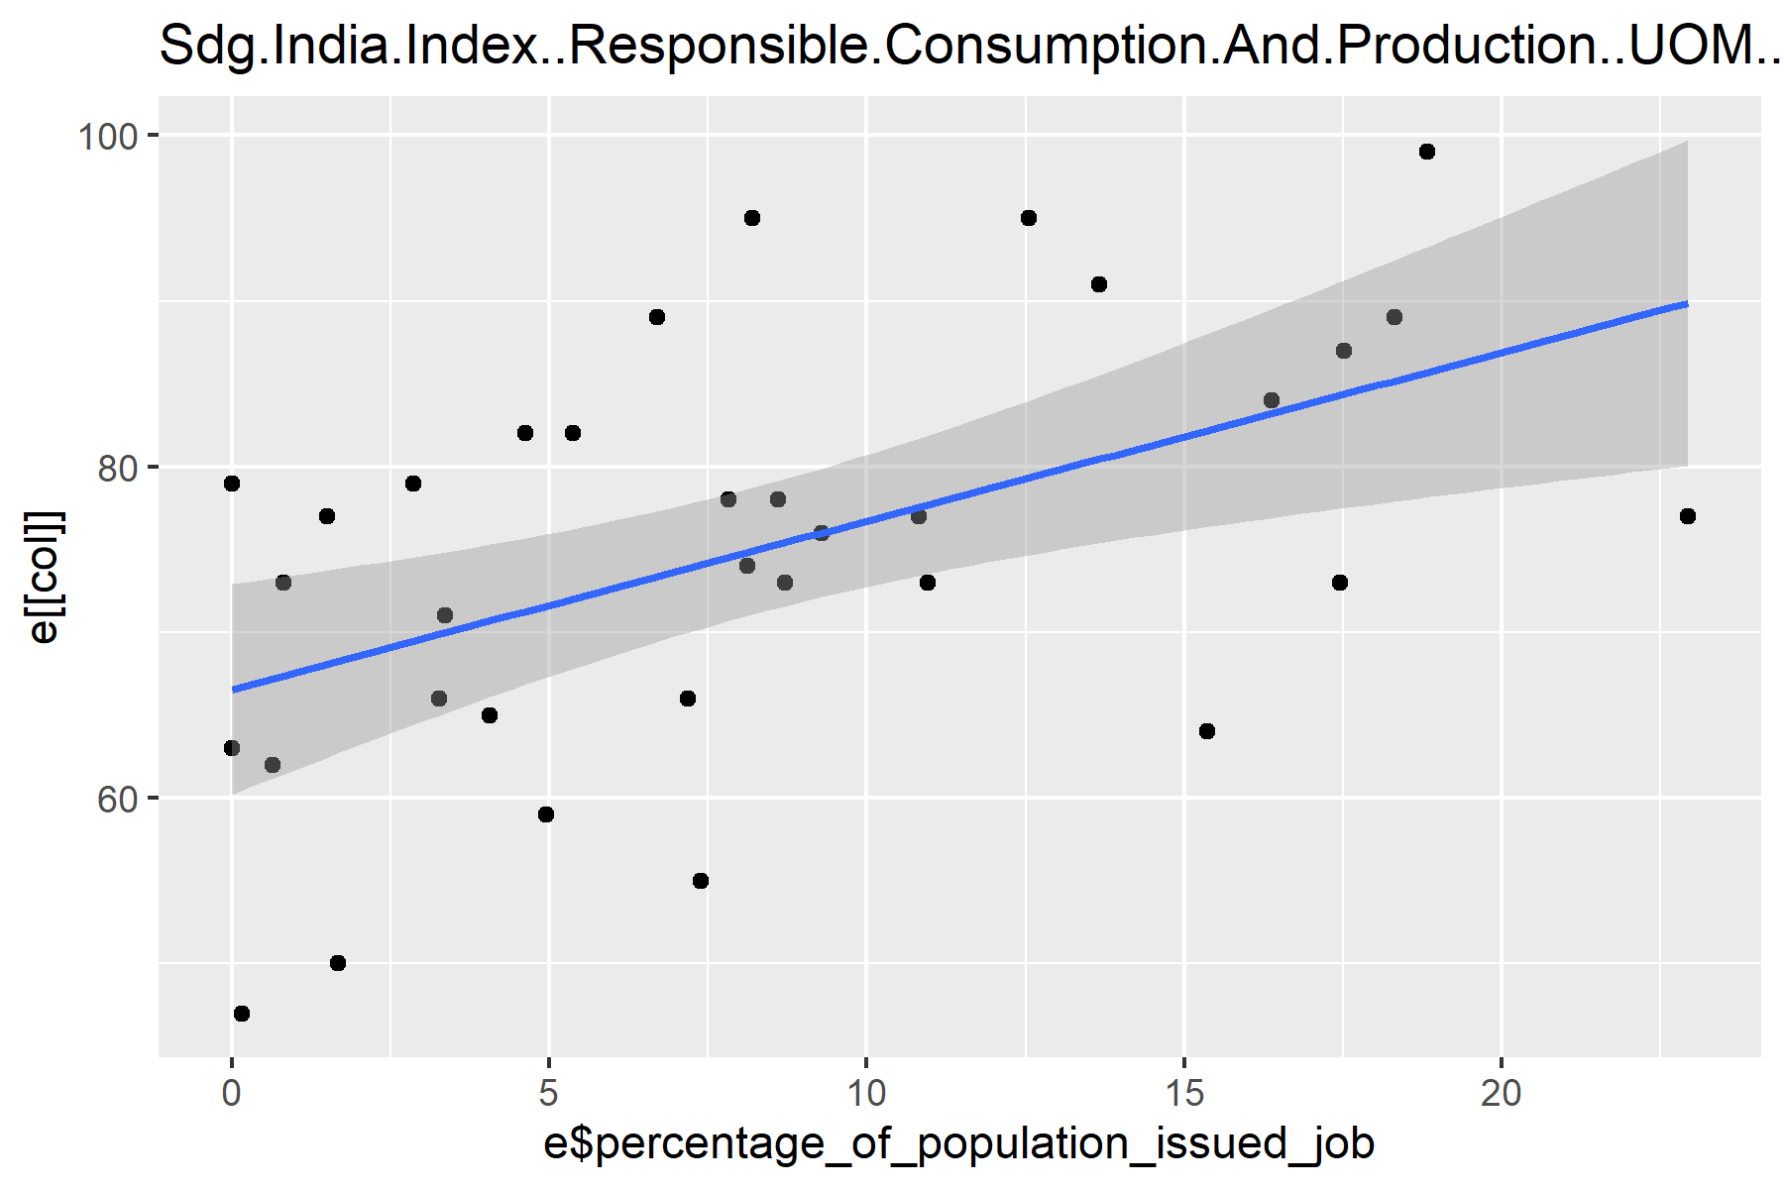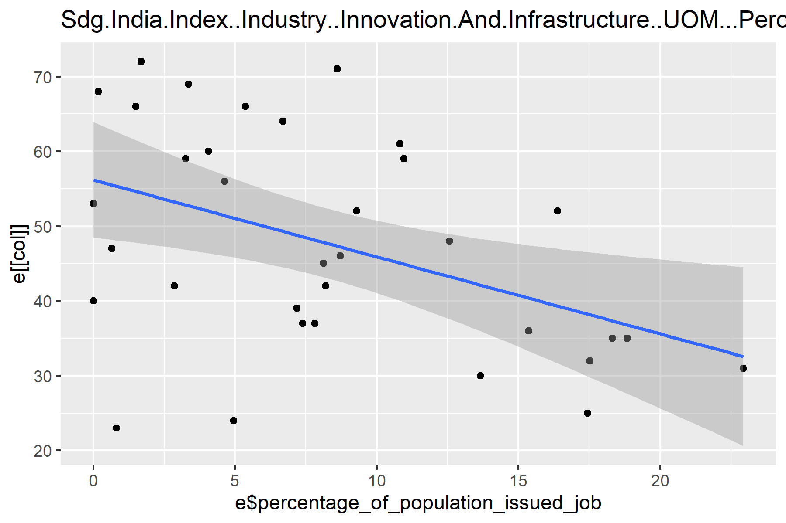
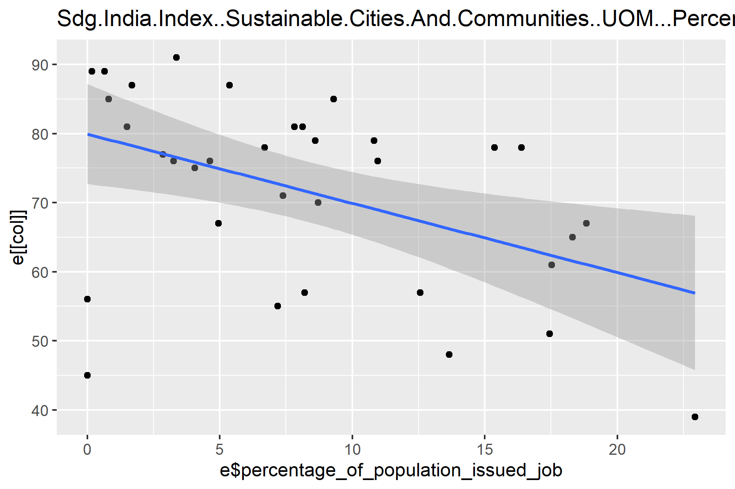

This analysis shows that factors such as education quality in a state/UT have a very weak correlation with the number of people employed under MGNREGA. Since the p-value is greater than 0.05, we fail to reject the null hypothesis. Therefore, the analysis does not provide sufficient evidence that there is a correlation between the percentage of the population under MGNREGA.
Taking our analysis a step further, we now analyse the above three factors. First, we compare each factor with one another to find a correlation among them.
Upon running a regression analysis of each indicator with the other two indicators, we get the following result:-

parameters | R squared | p-value | F-statistic
Sustainable Cities And Communities VS Industry Innovation And Infrastructure | 0.30937587 | 0.0006361201 | 14.3349
Responsible Consumption And Production VS Industry Innovation And Infrastructure | 0.02962852 | 0.3303409439 | 0.9770616
Industry Innovation And Infrastructure VS Sustainable Cities And Communities | 0.30937587 | 0.0006361201 | 14.3349
Responsible Consumption And Production VS Sustainable Cities And Communities | 0.11660217 | 0.0480999546 | 4.2237701
Industry Innovation And Infrastructure VS Responsible Consumption And Production | 0.02962852 | 0.3303409439 | 0.9770616
Sustainable Cities And Communities  VS Responsible Consumption And Production | 0.11660217 | 0.0480999546 | 4.2237701

From the above table, we can clearly see that:-
- Only industry innovation And infrastructure and Sustainable Cities and Communities have a mild correlation with each other.
- Apart from these two, any other possible combination leads to a low r square value or high p-value, indicating no/low correlation among them.
- This tells us we can use them in a multivariate analysis against the percentage of population under MGNREGA.
Thus, we use a multivariate analysis to further our study. Upon the multivariable analysis between the percentage of the population under MGNREGA vs sustainable cities and communities, industry innovation and infrastructure and responsible consumption and production, we get
the R-squared value came out to be 0.4079
with a p-value of 0.001151
However, upon deeper analysis, Responsible Consumption And Production played a significant role in this model, with industry innovation and infrastructure having a p-value of 0.1029 and Sustainable Cities and Communities having a p-value of 0.3727 in this model.

This shows that Responsible Consumption and Production is the only significant factor in correlating these factors with the percentage of population under MGNREGA.

Further analysing the sub-indicators of Responsible Consumption And Production using the data provided on the NITI Aayog data set site on the SDG 12 index. We get the following results,
parameters | R squared | P value | F statistic
Per Capita Fossil Fuel Consumption | 0.228504 | 0.004246 | 9.477858
Use of Nitrogenous Fertilizer Out of Total. N.P.K(Nitrogen, Phosphorus, Potassium) | 0.167269 | 0.01632 | 6.427772
Hazardous Waste Generated Per 1000 Population | 0.057214 | 0.194988 | 1.759909
Quantity of Hazardous Waste Recycled or Utilised to Total Hazardous Waste Generated | 0.019746 | 0.450857 | 0.58417
Plastic Waste Generated Per 1000 Population | 0.148034 | 0.02465 | 5.560193
Biomedical Waste Treated To Total Quality Of Biomedical Waste Generated | 0.001499 | 0.827903 | 0.048039
Installed Capacity of Grid-Interactive Bio Power Per 10 Lakh Population | 0.007312 | 0.698067 | 0.154679

From this, we can clearly see that only Per Capita Fossil Fuel Consumption (KG), Use of Nitrogenous Fertiliser out of Total N.P.K.(Nitrogen, Phosphorus, Potassium) and Plastic Waste generated per 1000 population have a mild correlation with the percentage of population under MGNREGA.

INTERPRETATION

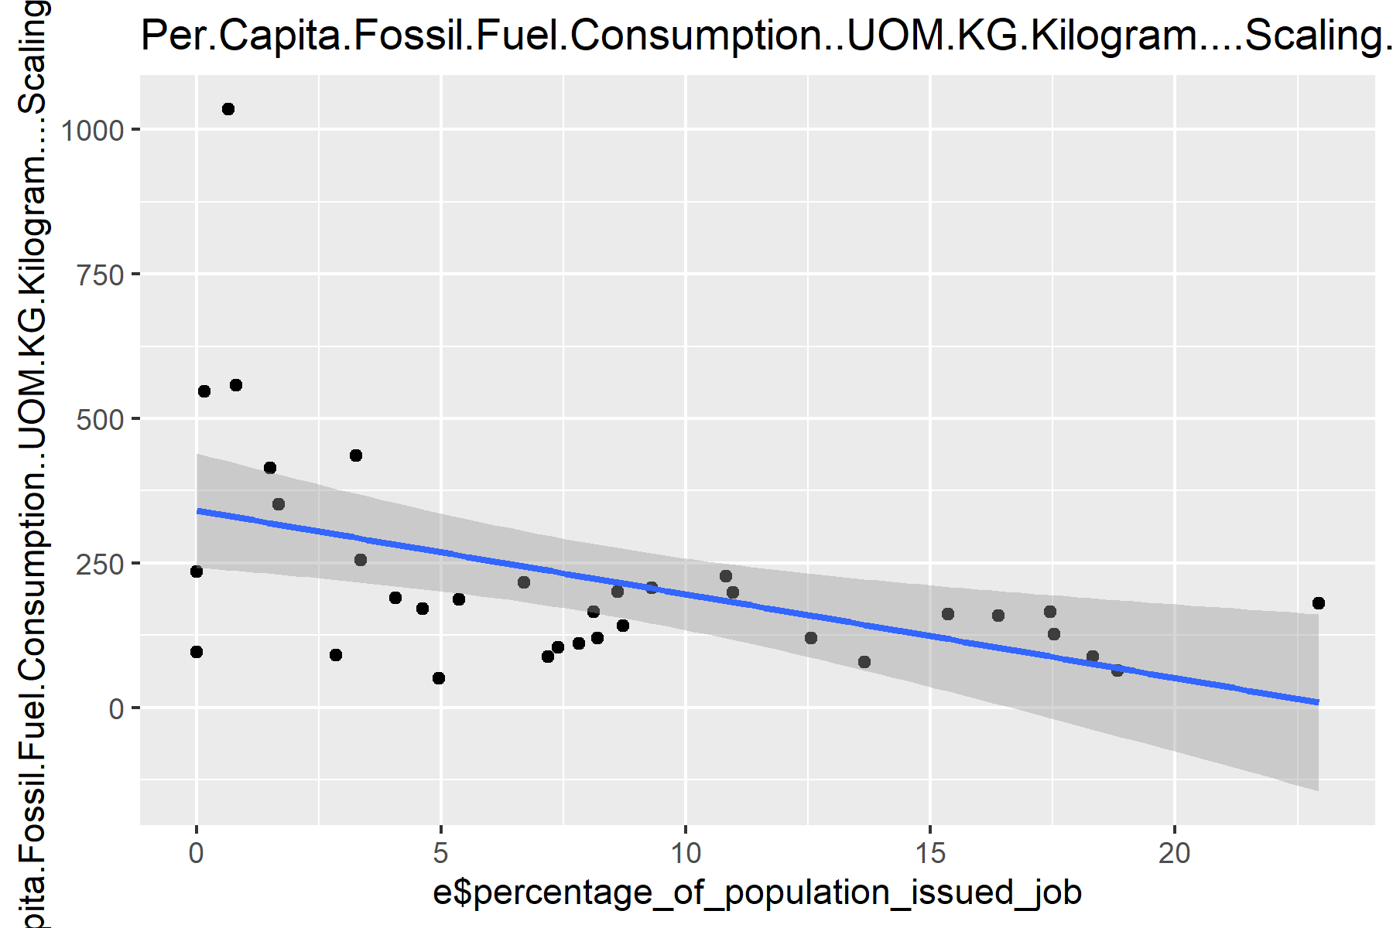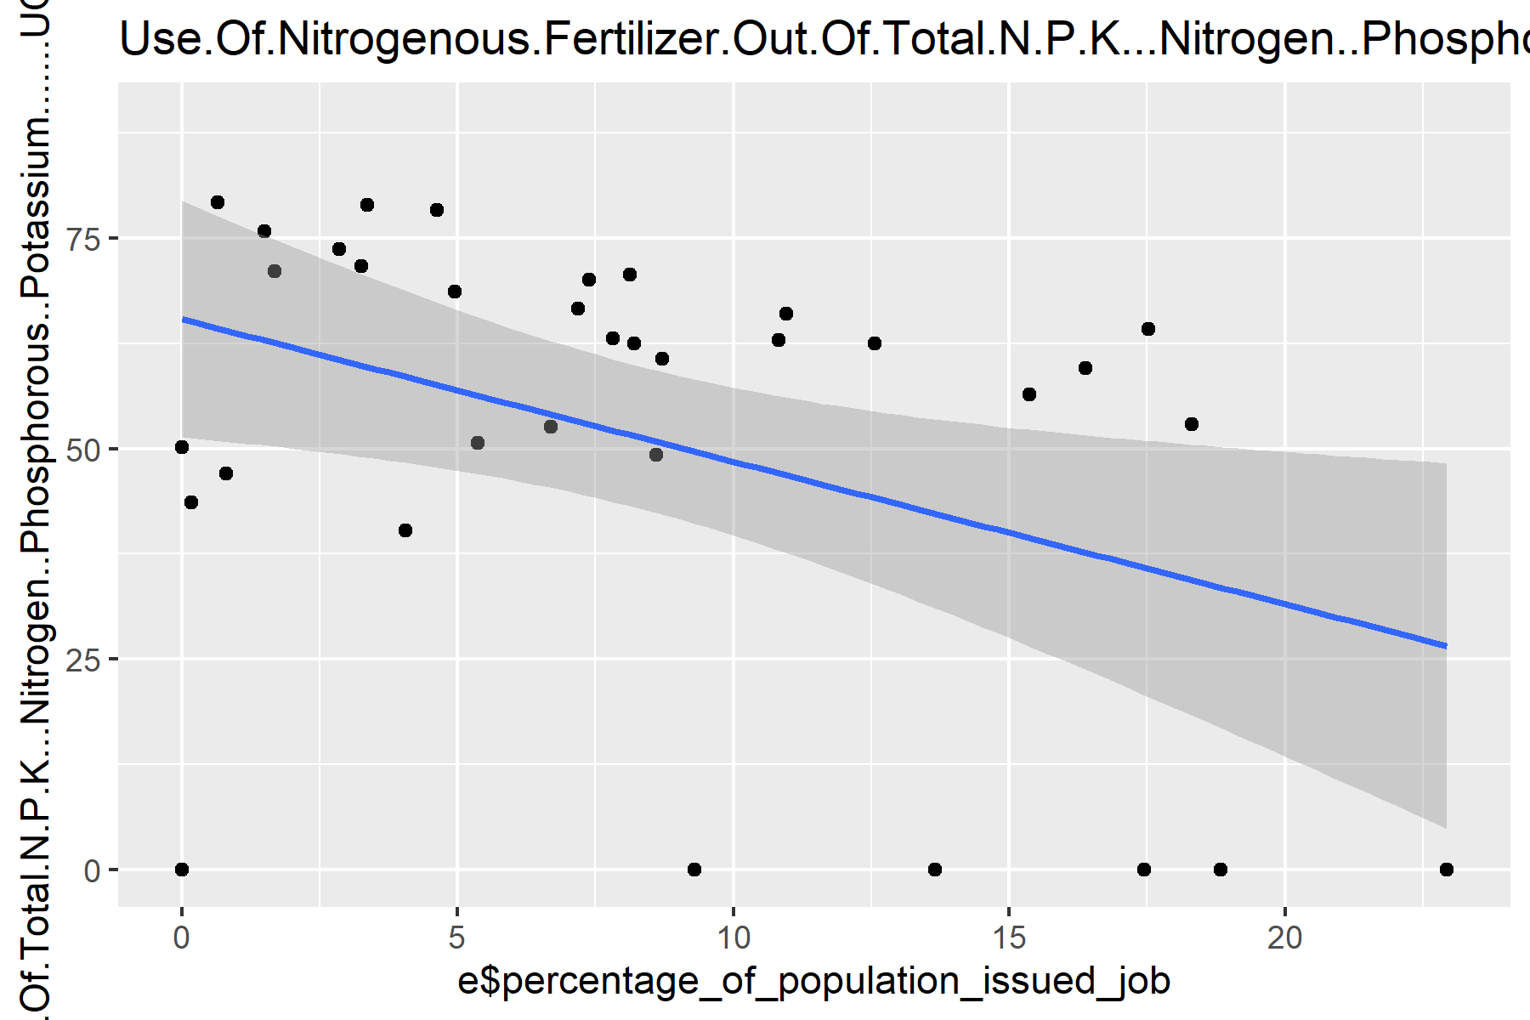
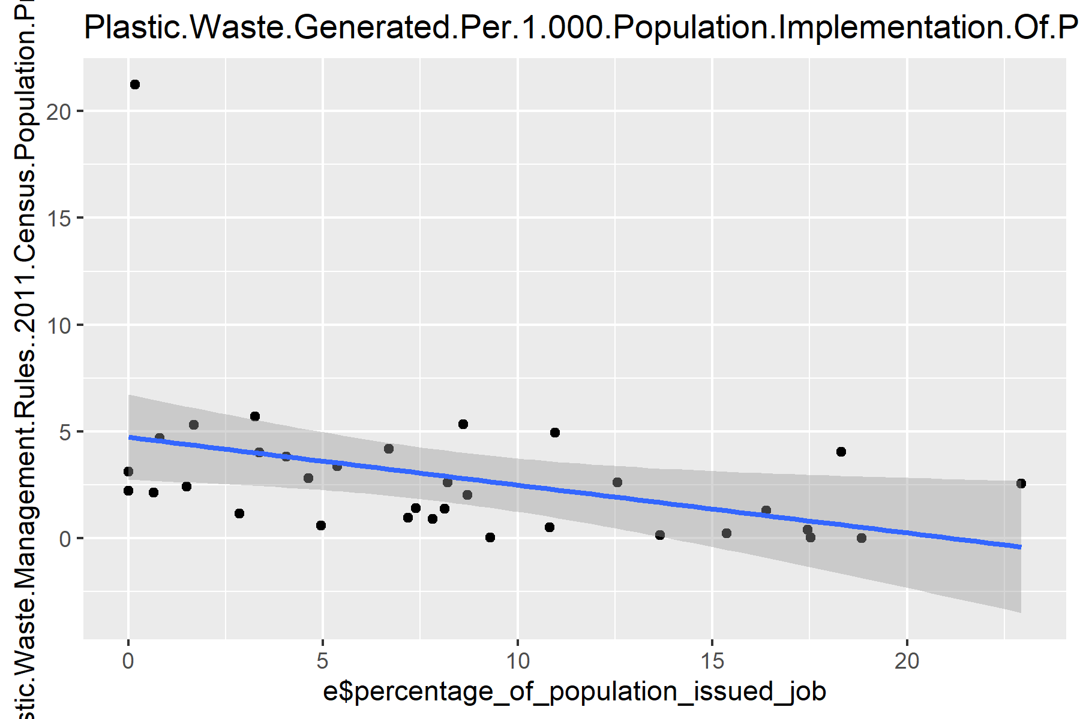
Since Per Capita Fossil Fuel Consumption (KG), Use Of Nitrogenous Fertilizer Out Of Total N.P.K.(Nitrogen,Phosphorous,Potassium) and Plastic Waste Generated per 1000 population are the factors with any significant correlation, we will look at the graph of these three factors, individually against the percentage of population under MGNREGA.
These graphs show a negative correlation between the sub-indicators and the percentage of population employed under MGNREGA.
However, when we ran the multivariate analysis of the percentage of population against Responsible Consumption and Production, Sustainable Cities and Communities and Industry Innovation and Infrastructure, we found a positive relation associated with Responsible Consumption and Production against percentage of population under MGNREGA.
This is consistent with the finding that Responsible Consumption And Production itself has a positive relation with the percentage of population under MGNREGA.
This result is likely because the lower the fossil fuel consumption, usage of nitrogenous fertilizer and generation of plastic by the population, the higher is the Responsible Consumption and Production index.
Also further analysising regression between population under MGNREGA and the above mentioned three sub indicators, we found that:
- Only use of Nitrogenous fertilizer out of Total N.P.K. was individually significant with a p- value of 0.036.
- Per capita Fossil Fuel consumption was borderline significant with a p-value of 0.055
- Plastic waste was no longer significant with a p-value of 0.170
The combined model with the above three sub-indicators had an R-squared value of 0.3722, F-statistic of 5.929 and a p-value of 0.0027.
This indicates that a state’s combined resource consumption pattern correlates closely with the population employed under MGNREGA.

CONCLUSION
This study set out to find whether indicators of the Sustainable Development Goals Index, particularly Education Quality, have a significant association with the percentage of population under MGNREGA, testing it against an initial hypothesis on the effect of education quality. We came to the conclusion that education quality can account for only 10 per cent of the variation in MGNREGA employment, but since the p-value exceeds 0.05 mark it is statistically insignificant.
Instead, we found that 3 factors showed a significant correlation. They are-
- Industry innovation and infrastructure, SDG 9, had a negative correlation
- Sustainable cities and communities, SDG 11, had a negative correlation
- Responsible consumption and production, SDG 12, had a positive correlation.
Upon further analysis, we found that SDG 9 and SDG 11 share substantial overlapping variance with each other and in a multivariate model, only SDG 12 was a significant factor.
Taking a closer look at the sub-indicators of SDG 12, we found only three sub-indicators- Per Capita Fossil Fuel Consumption, Uses of Nitrogenous Fertilizer out of total N.P.K and Plastic Waste Generated per 1000 Population, to show any association with the percentage of population under MGNREGA. They showed a negative correlation.
When combined in a single regression, only Uses of Nitrogenous Fertiliser out of total N.P.K. was significant, while the other variables were borderline significant or not significant at all.
Taken together, we can say that states/UTs with low industrial development/urban infrastructure and resource consumption intensity tend to have a higher percentage of people employed under MGNREGA.

Real-World Application And Policy Implications
While the findings in this study are correlational and should not be treated as an established relationship, they point towards several practical implications such as:-
- Targeted infrastructural development: The negative correlation between MGNREGA employment and SDG 9 and SDG 11 indicators suggests that greater urban infrastructure and industrial development tend to have lower MGNREGA employment. This may indicate that broader economic and infrastructure development is associated with reduced dependence on MGNREGA.
- Planning: Through the Sustainable Development Index published every year, we can get an idea of the demand for employment under MGNREGA. Indicators such as the ones mentioned in the study can give us signals based on the performance of that state in those indicators.

These implications are suggestions for further investigation, not policy-ready conclusions.
Any policy application would require further validation through panel data and through investigation.

REFERENCE AND DATA SOURCES
- NITI Aayog -SDG india index
url https://ndap.niti.gov.in/collection/Sustainable%20Development%20Goals%20(SDG)%20India%20Index/72

- MGNREGA- Employment Generated during the year 2025-2026
urlhttps://mnregaweb4.dord.gov.in/netnregarep/citizen_html/demregister.aspx?payload=LQBDp96wjzID4-mfmvNl-xfbbOkjZ-3S4n9GO1CunnkHKsBu1qw_UnFktaSxMt9fthdfF8ajS-GeYtwFm3HbNYFyD_izv-77Sxr2WfVZAW-Vg-mfcKQxRuNezxqB-cR-KOk-9VWUN1FFkg360WLAiw

- Population Census 2011 – Ministry of Health and Family Welfare
url1c3c2048814bd3747f44e661f8547055.pdf

